C. Write a brief reflection on the film you have watched.

(content) 5 sentences

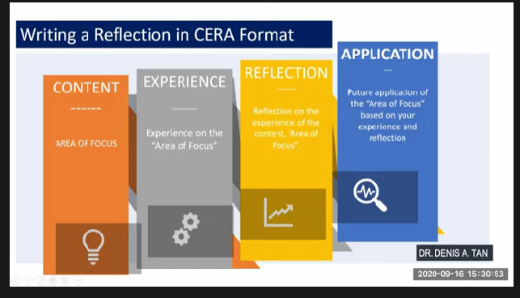

The content that the group found remarkable in the film was the part where they debate about social issues specifically, sex education and abortion. As college students, these are and should be the expected topics we talk or debate about. In our first year of college, we had a course about gender and society. Though it didn’t focus on sex education, it still did its part in educating us about gender, sex, and social issues. The group felt the content is something we have/had a lot of experience in and believed that it’s a content topic that is interesting to explore and talk about.

Jane had, though not in a very formal setting, experienced debating about abortion. They had a chance to pick a side and chose the affirmative, as in, ‘yes’ to legalizing abortion in the Philippines. Just like in the film and how debating usually works, she had done her research to support her stand.

Reflection:

Though it was just a casual classroom debate and not a very formal one, Jane had still seriously done her research to support her stand. Debating has always been something one can’t do mindlessly regardless of the topic. The experience taught her that it’s better to be thorough about researching the topic and have lots of spare supporting documents than be casual about it and have nothing to present

Application:

The debate Jane had experienced made her be meticulous about researching not only for debating but also in making argumentative papers. Research is an integral aspect of a debate and the files you recovered will be something that could help you win your side. In the film, the Harvard team almost succeeded in dominating the competition through their intensive research.

*Listen To Me* revolves around a group of college students who are members of their College’s debate team. Three members of the team namely, Tucker, Monica, and Garson have an exceptional talent for debating and have been leading the team to victory in every debate competition. The debate circle grooms their debaters to prepare to proceed with law or to be prepared with entering politics after college. The goal, aside from winning each competition, is to have as many connections with influential individuals as possible. Although these three came from different family backgrounds with one (Garson) being a child of an influential family, they each experience their hardships and happiness. They learn about life, passion, friendship, and most specifically, love and politics during their debate journey towards their final struggle in front of the Supreme Court.

The movie was released in 1988 and issues such as abortion and sex education which are still crucial topics in today’s time